Faiza Abdullah

Lab 02 on MSLE Skillable Platform

ITAI 2376 Deep Learning in Artificial Intelligence

Professor: [Patricia Mcmanus](https://eagleonline.hccs.edu/courses/282423/users/264039)

**REFLECTIVE JOURNAL: ANALYZE IMAGES IN AZURE AI FOUNDRY PORTAL**

**PROOF OF COMPLETION:**

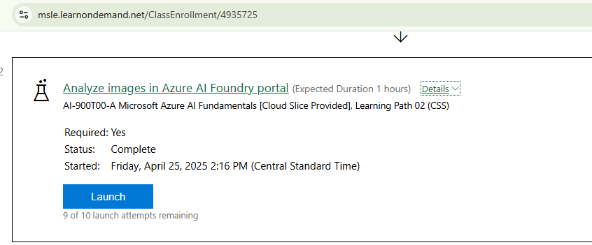

**INTRODUCTION**

In completing the second lab of the AI-900T00-A Microsoft Azure AI Fundamentals course, I explored the Azure AI Vision service through the Azure AI Foundry portal. The lab focused on analyzing images using Azure's AI capabilities, specifically leveraging the Azure AI Vision service to extract insights from visual data.

**LAB OBJECTIVES AND PROCESS**

The lab was designed to provide hands-on experience with the Azure AI Vision service, enabling me to upload images, analyze them, and interpret the results using pre-built AI models. The key objectives included setting up an Azure AI Vision resource, uploading images to the Azure AI Foundry portal, and using the service to perform tasks such as object detection, image tagging, and extracting descriptive information from images.

**WHAT I DID**

* Accessed the Azure AI Foundry Portal: I logged into the portal on the Microsoft Learn on Demand platform (https://msle.learnondemand.net) and created an Azure AI Vision resource.

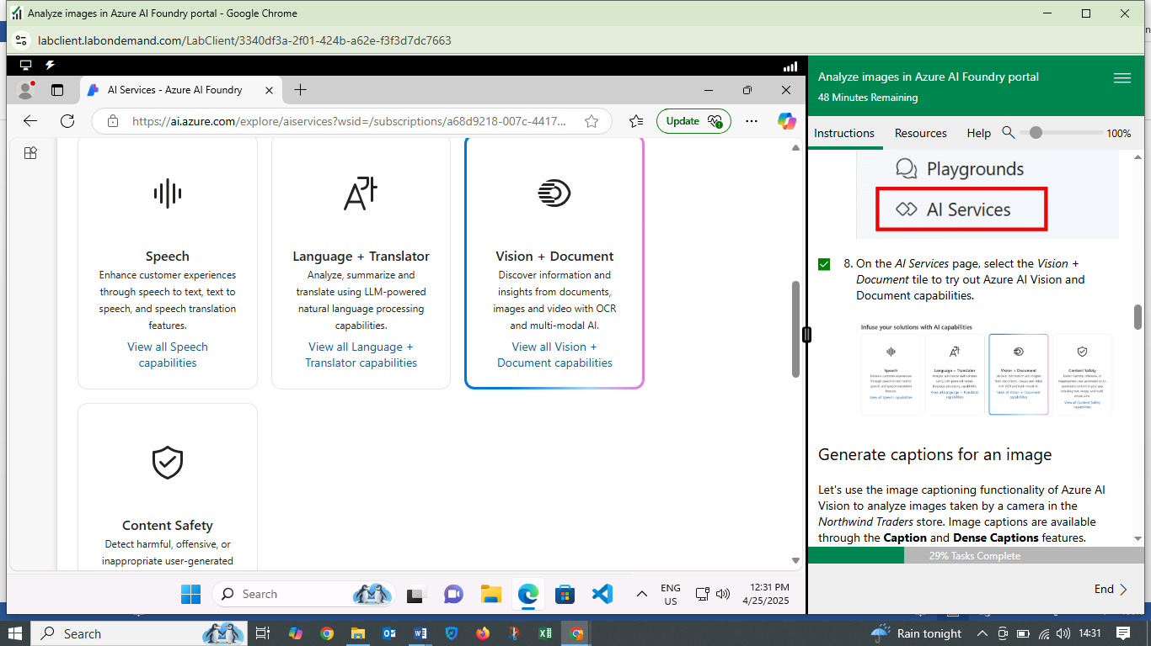

* Uploaded Images: I uploaded images related to Northwind Traders, a fictional company, to simulate a retail or inventory management context where images of products or store shelves are analyzed to extract insights. The images included product images or shelf displays (e.g., images depicting items like bottles, boxes, or retail setups) for object detection, image tagging, and generating descriptive captions replicating a real-time business scenario.

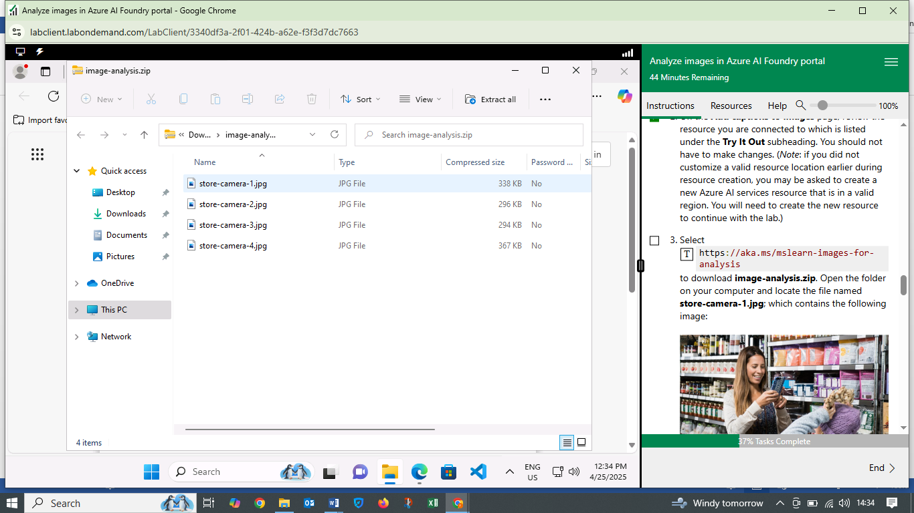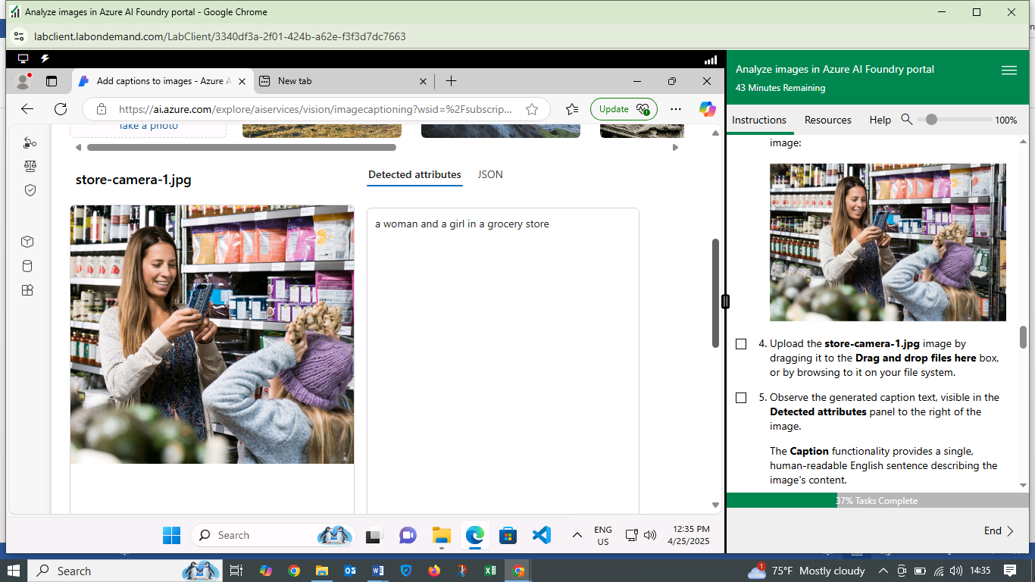

* Analyzed Images: Using the Azure AI Vision service, I processed the images to generate outputs, including:
  + Tags: Keywords describing objects or elements in the image (e.g., "bottle," "shelf," "product"), each with a confidence score.

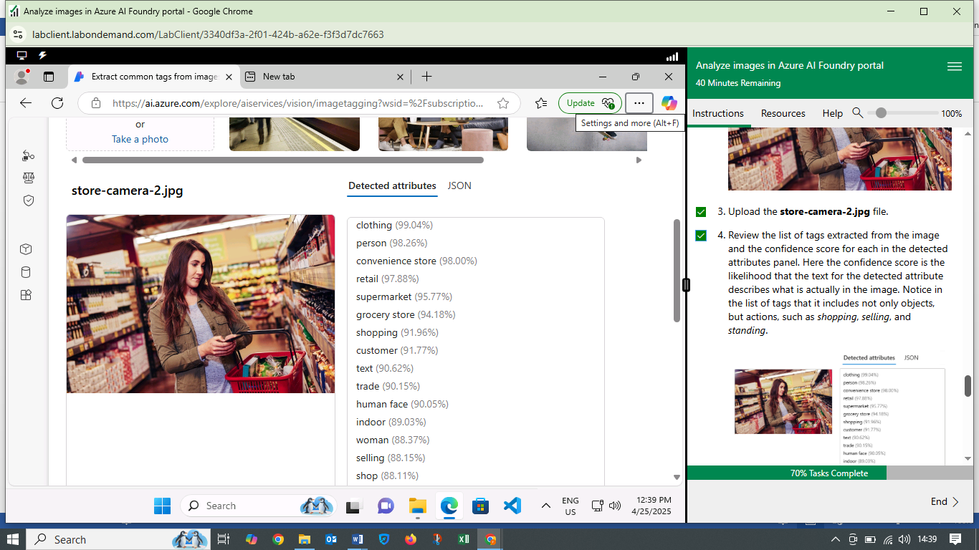

* + Captions: Descriptive sentences summarizing the image content (e.g., "A shelf with various bottled products"), with a confidence score.
  + Object Detection: Bounding boxes around identified objects with labels (e.g., individual bottles or boxes) with labels and associated confidence scores (e.g., "bottle: 0.95")

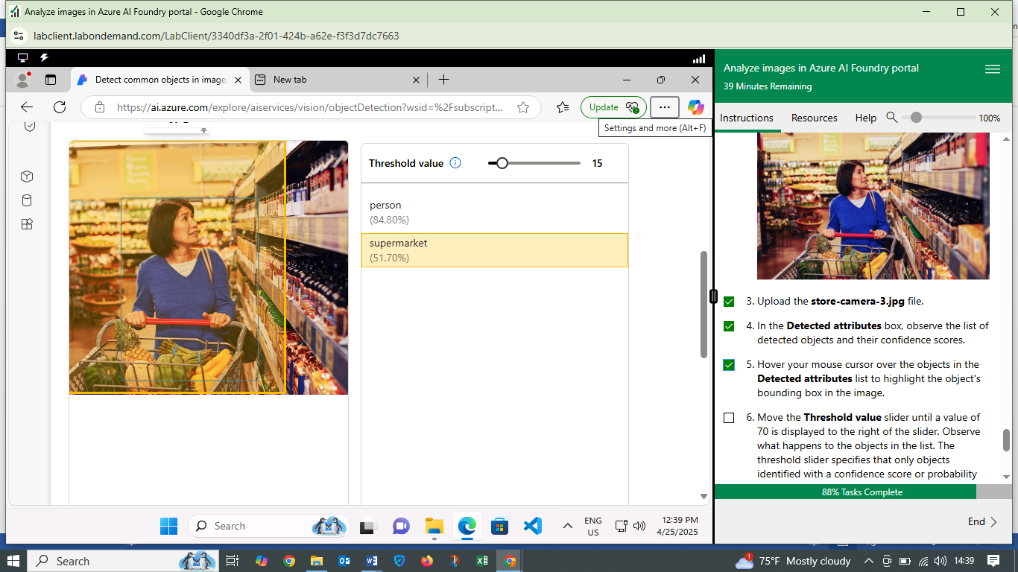

* Reviewed Results: I examined the outputs displayed in the portal, including visual overlays (bounding boxes) and JSON (a structured data format that encapsulates the results of the Azure AI Vision service's image analysis) responses, to understand the AI's interpretation of the images.
* Explored Features: I adjusted settings, such as confidence thresholds, to filter results and explored the JSON output for detailed analysis.

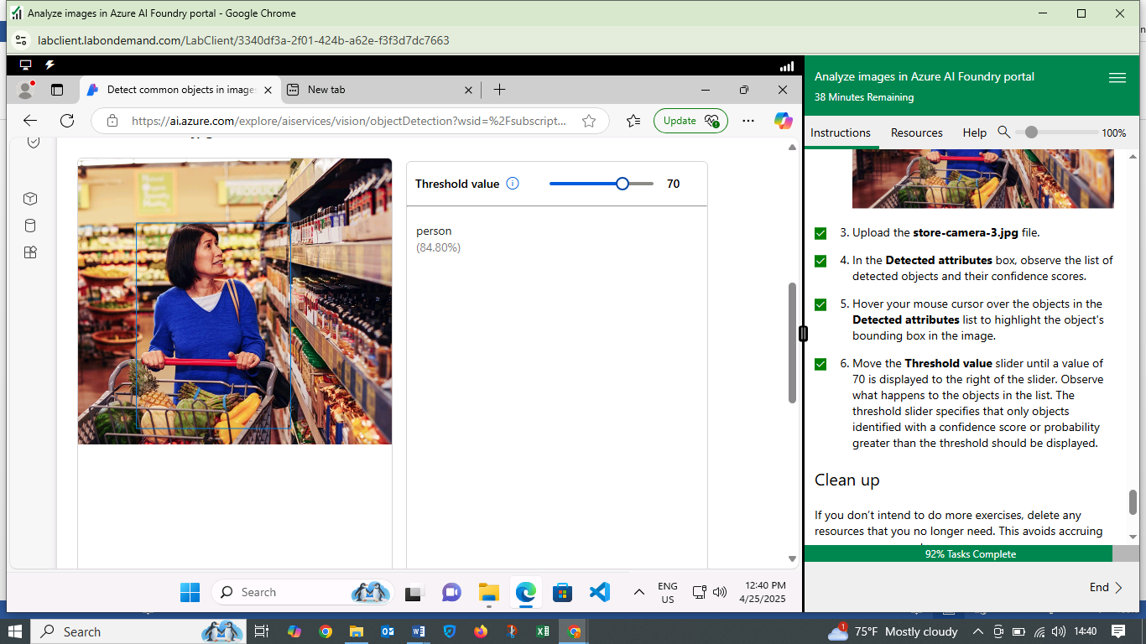

The Northwind Traders example illustrated how Azure AI Vision can analyze retail images to support inventory management. I uploaded and analyzed images, generating tags, captions, and object detections with confidence scores, all documented in the screenshots. The JSON output provided a detailed, structured summary of the analysis, while confidence scores enabled me to filter reliable results, as seen when adjusting thresholds for detected bottles and boxes. This hands-on experience highlighted the service's utility in real-world business applications.

**WHAT I LEARNED**

Key takeaways include:

* Functionality of Azure AI Vision: I learned how the service uses pre-trained machine learning models to analyze images without requiring custom model training. The ability to generate tags, captions, and object detections from images showcased the power of Azure's pre-built AI capabilities.
* Ease of Use: The Azure AI Foundry portal provided an intuitive interface for interacting with the Vision service. Uploading images and reviewing results was straightforward, making it accessible even for beginners in AI.
* Real-World Applications: The lab highlighted how Azure AI Vision can be applied in scenarios such as automated content moderation, accessibility enhancements (e.g., generating image descriptions for visually impaired users), and inventory management through object detection.
* Interpreting AI Outputs: Working with JSON outputs and confidence scores gave me insight into how AI models quantify their predictions. This was particularly evident when adjusting thresholds to filter results, which helped me understand the balance between precision and recall in AI systems.

**CHALLENGES FACED**

While the lab was well-structured, I encountered a few challenges:

* Navigating the Portal: Initially, finding the correct section in the Azure AI Foundry portal to create the Vision resource was slightly confusing due to the portal's extensive options. However, the lab instructions and screenshots helped me locate the necessary tools.
* Interpreting JSON Outputs: Understanding the structure of the JSON responses, especially for complex images with multiple objects, required careful attention. I overcame this by cross-referencing the lab documentation and experimenting with different images to see how the outputs varied.
* Image Selection: Choosing images that would yield meaningful results was a minor challenge. Some images produced fewer tags or less accurate captions, which prompted me to experiment with diverse images to better understand the model's capabilities and limitations.

These challenges were manageable and provided opportunities to deepen my engagement with the Azure AI Vision service. By troubleshooting and iterating, I gained a more comprehensive understanding of the tool's functionality.

**INSIGHTS GAINED**

* Power of Pre-Built AI: The Azure AI Vision service demonstrated how pre-built models can deliver robust results without requiring extensive AI expertise. This accessibility makes it a practical tool for businesses and developers looking to integrate AI into their workflows.
* Importance of Data Quality: The accuracy of the AI Vision outputs depended heavily on the quality and clarity of the input images. This reinforced the importance of data preprocessing in AI applications.
* Confidence Scores and Decision-Making: Working with confidence scores highlighted the probabilistic nature of AI predictions. This insight is crucial for applications where reliability is critical, such as medical imaging or autonomous systems.
* Scalability of Azure AI: The lab showcased how Azure's cloud-based infrastructure enables scalable AI solutions. The ability to process multiple images quickly and efficiently underscored the platform's potential for enterprise-level applications.

**CONCLUSION**

Completing the Azure AI Vision lab was a rewarding experience that enhanced my technical skills and conceptual understanding of AI in the cloud. By successfully navigating the Azure AI Foundry portal, analyzing images, and interpreting results, I gained hands-on experience with a powerful AI tool. The challenges I faced, such as navigating the portal and interpreting outputs, were valuable learning opportunities that strengthened my problem-solving skills. The insights I gained about pre-built AI models, data quality, and confidence scores will inform my future work with Azure AI technologies.

This lab has solidified my appreciation for the accessibility and scalability of Azure AI services. As I progress in the AI-900 learning path, I look forward to exploring other Azure AI tools, such as natural language processing and predictive modeling, and applying these skills to real-world scenarios.